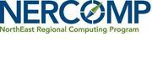
Professional Development Organizer Submission Form Webinar
*Please use this form to submit the information required for posting and advertising your webinar to Amy Schack, aschack@nercomp.org by the due dates specified*

Webinar Title:

Abstract/Summary of Webinar (please limit to 150 words) including intended audiences:

2-3 Learning Objectives (what will attendees come away from your workshop with):

How do you plan to fill 40-45 minutes of time during the webinar/online class (ie: presentation, panel with questions prepared in advance, polls etc):

Additional speaker info needed:
Speaker name, title, institution, bio, and email address

